**SQL for Economic Impacts of Road Accidents & Casualties on the GDP of the UK.**

1. **Take a view at the tables:**
2. **UK_Road_Accident table**

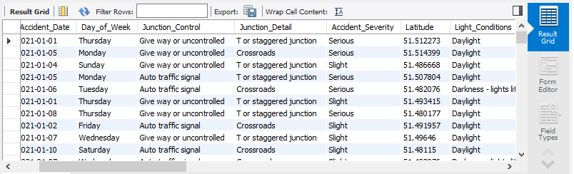SELECT * FROM `uk road accident - 2021 & 2022 dataset`.uk_road_accidents**;**

1. **Cost table**

SELECT * FROM `uk road accident - 2021 & 2022 dataset`.cost;

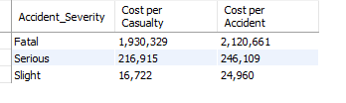

1. **Data Wrangling:**
2. **Change ‘Fetal’ to ‘Fatal’**

UPDATE uk_road_accidents

SET Accident_Severity='Fatal'

WHERE Accident_Severity='Fetal';

1. **To verify the Change**

SELECT * FROM `uk road accident - 2021 & 2022 dataset`.uk_road_accidents

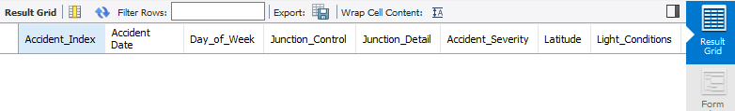WHERE Accident_Severity = 'Fetal';

1. **Create some needed columns,and join the two tables together:**
2. **Create Month_Name Column.**

SELECT Accident_Date, monthname(Accident_Date) as Month_Name

FROM `uk road accident - 2021 & 2022 dataset`.uk_road_accidents;

ALTER TABLE `uk road accident - 2021 & 2022 dataset`.uk_road_accidents

ADD Month_Name text;

UPDATE `uk road accident - 2021 & 2022 dataset`.uk_road_accidents

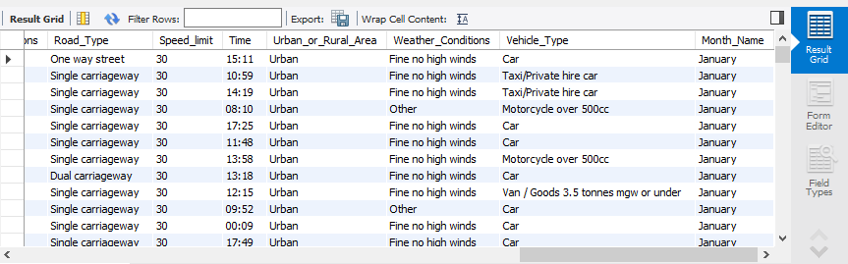SET Month_Name = monthname(Accident_Date);

1. **Create Year Column**

SELECT Accident_Date, year(Accident_Date) as Year

FROM `uk road accident - 2021 & 2022 dataset`.uk_road_accidents;

ALTER TABLE `uk road accident - 2021 & 2022 dataset`.uk_road_accidents

ADD Year int2;

UPDATE `uk road accident - 2021 & 2022 dataset`.uk_road_accidents

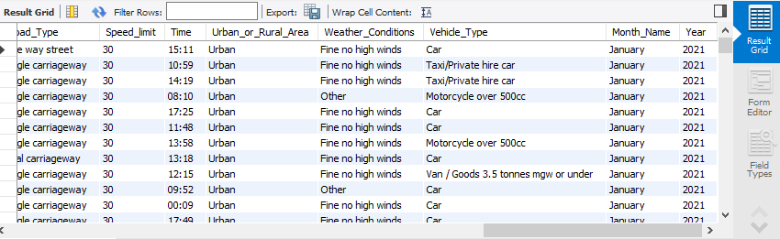SET Year = year(Accident_Date);

1. **Join uk_road_accidents and cost tables together.**

SELECT u.Accident_Date, u.Day_of_Week, u.Junction_Control, u.Junction_Detail, u.Accident_Severity,

u.Light_Conditions, u.Number_of_Casualties, u.Number_of_Vehicles,

u.Road_Surface_Conditions, u.Road_Type, u.Time, u.Urban_or_Rural_Area, u.Weather_Conditions,

u.Vehicle_Type, u.Month_Name, u.Year,

c.Casualty_cost, c.Accident_cost

FROM `uk road accident - 2021 & 2022 dataset`.uk_road_accidents as u JOIN `uk road accident - 2021 & 2022 dataset`.cost as c ON u.Accident_Severity = c.Accident_Severity.

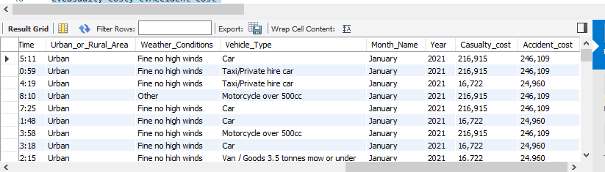

1. **Create new table that joined the two tables together named Economic_ Impacts_of_Road_Accidents_on_UK_GDP.**

CREATE TABLE economic_impacts_of_road_accidents_on_uk_gdp

SELECT u.Accident_Date, u.Day_of_Week, u.Junction_Control, u.Junction_Detail, u.Accident_Severity,

u.Light_Conditions, u.Number_of_Casualties, u.Number_of_Vehicles,

u.Road_Surface_Conditions, u.Road_Type, u.Time, u.Urban_or_Rural_Area, u.Weather_Conditions,

u.Vehicle_Type, u.Month_Name, u.Year,

c.Casualty_Cost, c.Accident_Cost

FROM `uk road accident - 2021 & 2022 dataset`.uk_road_accidents as u

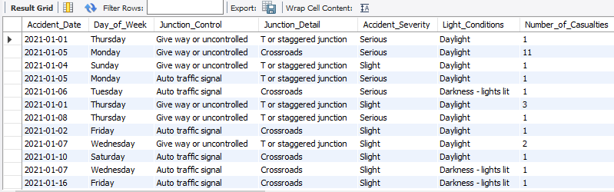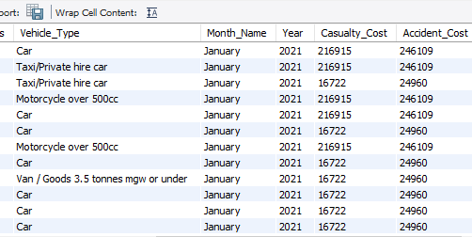JOIN `uk road accident - 2021 & 2022 dataset`.cost as c ON u.Accident_Severity = c.Accident_Severity;

1. **Create new columns in Economic_Impacts_of_Road_Accidents_on_UK_GDP table.**
2. **Add a new column - Total_Casualty_Cost**

SELECT Number_of_Casualties, Casualty_Cost, (Number_of_Casualties * Casualty_Cost) as Total_Casualty_Cost

FROM `uk road accident - 2021 & 2022 dataset`.economic_impacts_of_road_accidents_on_uk_gdp;

ALTER TABLE `uk road accident - 2021 & 2022 dataset`.economic_impacts_of_road_accidents_on_uk_gdp

ADD Total_Casualty_Cost bigint;

UPDATE `uk road accident - 2021 & 2022 dataset`.economic_impacts_of_road_accidents_on_uk_gdp

SET Total_Casualty_Cost = (Number_of_Casualties * Casualty_Cost);

1. **Add a new column - Total_Accident_Cost**

SELECT Number_of_Casualties, Accident_Cost, (Number_of_Casualties * Accident_Cost) as Total_Accident_Cost

FROM `uk road accident - 2021 & 2022 dataset`.economic_impacts_of_road_accidents_on_uk_gdp;

ALTER TABLE `uk road accident - 2021 & 2022 dataset`.economic_impacts_of_road_accidents_on_uk_gdp

ADD Total_Accident_Cost bigint;

UPDATE `uk road accident - 2021 & 2022 dataset`.economic_impacts_of_road_accidents_on_uk_gdp

SET Total_Accident_Cost = (Number_of_Casualties * Accident_Cost);

1. **Add a new column - Total_Payment**

SELECT Total_Casualty_Cost, Total_Accident_Cost, (Total_Casualty_Cost + Total_Accident_Cost) as Total_Payment

FROM `uk road accident - 2021 & 2022 dataset`.economic_impacts_of_road_accidents_on_uk_gdp;

ALTER TABLE `uk road accident - 2021 & 2022 dataset`.economic_impacts_of_road_accidents_on_uk_gdp

ADD Total_Payment bigint;

UPDATE `uk road accident - 2021 & 2022 dataset`.economic_impacts_of_road_accidents_on_uk_gdp

SET Total_Payment = (Total_Casualty_Cost + Total_Accident_Cost);

